**Software Development Life Cycle VS Systems Development Life Cycle:**

To understand the difference, we need to first understand the difference between software and system.

Software – Enables an existing business process ‘as is.’ software is a functional suite of software modules that are often, but not exclusively, a single application

System – Delivers rich functionality to a wider range of business processes with much more end-to-end thinking. A system is often the choice when there is more than one software component, along with the necessary infrastructure and technical architecture to meet the needs of the business. Rather than finding an application that solves the majority of business processing issues, a system is chosen to meet more specific business needs and is more tailored and customized to suit the different departments and functions within an organization.

Software development life cycle only looks at software components development planning, technical architecture, software quality testing and deployment of working software.

System development life cycle involves end-to-end People, process, Software/Technology deployment.  This includes Change Management, training, Organizational updates, also.

The development lifecycles for both pretty much involve the same phases:

**Software Development Life Cycle**

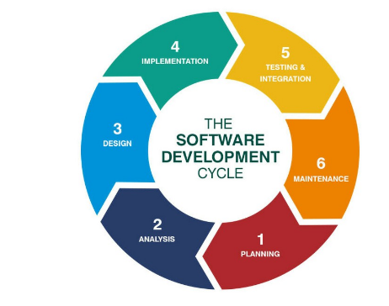

**Systems Development Lifecycle:**

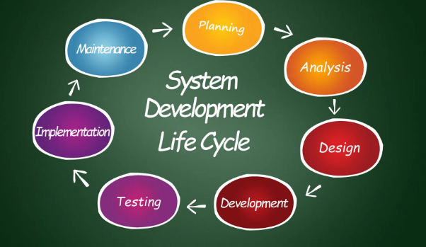

**Definition of Done:**

When both coding/programming and validating/testing aspects are completed

For a product/software: when coding is done to standards, reviewed, implemented, tested, integrated and documented

For a service: every task in the user story is completed, any work created (this may be emails, excel sheets, presentations or any other format) is attached to the user story for the Product Owner to review and approve